Critical Incident Paper

The economic fallout of the United Kingdom leaving the European Union

Mariia Lukashenko
ECO-314
Dr. Baranes
December 11, 2025

In 2016, the United Kingdom held a referendum on whether it should remain in the European Union or leave it. The “leave” side won by a narrow margin of 51.9% to 48.1%, and on January 1st, 2020, the UK officially left the EU (L’Hotellerie-Fallois P. 2020). This paper, specifically, will investigate the economic consequences of Brexit. In particular, the paper examines how the UK’s departure from the EU has altered its pattern of trade, production and factor returns, and how these changes affect overall welfare, using theoretical models, welfare diagrams and a game-theoretic framework.
The economic fallout of Brexit is easier to understand once we are clear about how things worked before 2016. The EU is a union of 27 countries that provides political stability, free movement of people, and access to the world’s largest single market, where goods and many services move with no tariffs and few non-tariff barriers (Chart 1.1) (European Union, n.d). Open borders and unrestricted intra-EU migration let workers and firms match across countries, supporting integrated value chains. For the UK, this meant exceptionally deep trade links: controlling for standard factors like size and distance, UK trade with the EU was about 55% higher than would be expected without membership (Webb & Ward, 2021). In 2013, UK–EU goods trade totaled roughly £364 billion, implying an “EU effect” of around £130 billion in extra trade compared with only about £43 billion in goods trade with China (Chart 1.2) (Springford, 2014).
In addition, UK has been very good at attracting foreign direct investment, especially from the EU and the US (Chart 1.7). Over time, the EU has become the dominant source: its share of the UK’s inward FDI stock rose from about 30% in 1997 to around 50% by 2012, and EU FDI is now roughly 30% of UK GDP (Ward, 2025). This reflects the UK’s openness, strong institutions, skilled labor, and—crucially—its position inside the EU single market. That openness, however, also creates a risk. Foreign-owned firms are more mobile and more likely to shift activity if the UK loses easy access to EU customers. Manufacturing FDI is particularly exposed, especially car production and food processing, which are tightly linked to European supply chains. High-value services are harder to move, but some financial and tradable service activity would likely drift into the EU over time. Outside the EU, the UK would also have less bargaining power in trade and investment talks, making it difficult to replace EU market access with equally deep deals elsewhere.
Considering these factors and many others, many in the UK came to see EU membership as a constraint rather than an asset. Concerns about the European debt crisis, immigration, terrorism and the EU’s perceived control over UK rules and budgets fed into the “Leave” campaign. Supporters of Brexit argued that EU regulations were holding back British entrepreneurship and growth, sometimes invoking symbolic examples such as the “bendy banana law” as evidence of overregulation. They wanted tighter border control, less migration from other EU countries and more national control over trade, regulation and economic policy (Wikipedia, n.d). The 2016 referendum and the subsequent withdrawal process were presented as a route to greater sovereignty and new global trade opportunities. The economic question, however, is how this new independence – together with new trade frictions and policy uncertainty – has altered the UK’s long-run growth, trade performance and living standards.
Evidence suggests that Brexit has imposed sizeable, measurable costs on the UK economy. The pound fell sharply after the 2016 referendum and by early 2021 was about 15% weaker against the euro than in June 2016, raising import prices, inflation, and squeezing real incomes. The UK’s Office for Budget Responsibility estimates that total exports and imports are now around 15% lower than they would have been if the UK had remained in the EU, while macro studies suggest UK GDP is roughly 6–8% smaller than in a no-Brexit scenario, with other estimates putting current losses at 2–3% of GDP and rising to 5–6% (about £2,300 per person) by 2035 (Bloom, 2024). On the fiscal side, some analyses indicate Brexit may be costing the Treasury up to £90 billion a year in lost tax revenue, leaving the average Briton an estimated £2,700–£3,700 worse off in terms of GDP per head (Devlin, 2025). Facing this, Chancellor Rachel Reeves has argued that the UK must rebuild closer ties with the EU and use rising US tariffs as a chance to present the UK as a more stable and predictable place for investment (Islam & Smith, 2025)
Taken together, these developments motivate the central question of this critical incident: through which trade, production and factor-allocation mechanisms has Brexit translated into a loss of UK welfare? The sections that follow use standard models of trade creation and diversion, factor-endowment theory and a Prisoner’s Dilemma framework to organize and interpret this economic fallout.

Critical Incident Overview
This critical incident highlights that Brexit is not only a political rupture but a fundamental economic one rooted in core ideas from international economics. Before 2016, the UK was tightly integrated into the EU’s single market: trade costs were low, intra-industry trade and cross-border supply chains flourished, and labor and capital could move with relatively few frictions. In that environment, comparative advantage and specialization operated over a large, unified market, allowing UK firms to scale across Europe and reinforcing productivity and growth. By contrast, leaving the EU has introduced new barriers—customs checks, regulatory divergence, rules of origin and tighter migration rules—that raise trade costs, reduce factor mobility and make the UK a less attractive platform for investment. Over time, these frictions do not just create one-off adjustment shocks; they shift the UK onto a lower-growth trajectory, with smaller effective markets, weaker competitive pressures and diminished dynamic gains from trade.

Learning Objectives
By the end of this critical incident, readers should be able to:
- Explain how Brexit reduced UK welfare using the trade creation vs. trade diversion framework and partial-equilibrium diagrams.
- Analyze how Brexit changed the UK’s pattern of production and factor returns using the Heckscher–Ohlin and Stolper–Samuelson models.
- Use a Prisoner’s Dilemma payoff matrix to show how strategic interaction between the UK and the EU led to a suboptimal, lower-welfare equilibrium after Brexit.

Questions -
- Why does Brexit reduce the efficiency of the UK’s trading pattern by eliminating trade-creation gains with the EU, and why are the offsetting reductions in trade diversion too small to prevent a net welfare loss?

Define:
- Customs union / single market – a group of countries that remove tariffs between each other and usually share a common external tariff toward non-members.
- Trade creation – when integration makes a country switch from high-cost domestic production to lower-cost imports from a partner. Imports rise, domestic output falls, and total welfare increases because consumers get cheaper goods and resources are used more efficiently.
- Trade diversion – when integration makes a country switch from low-cost imports from the rest of the world to higher-cost imports from a partner, just because the partner’s imports become tariff-free. Trade volume may rise, but some of it is now coming from a less efficient source, so there can be a welfare loss.
- Net welfare effect – the sum of consumer surplus, producer surplus and tariff revenue.
Diagram:
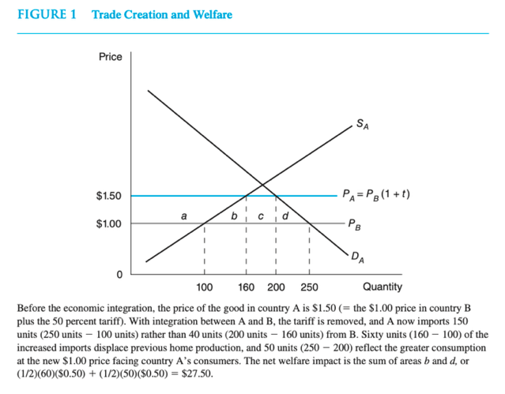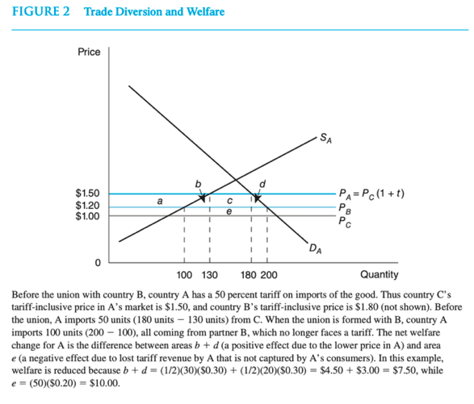
Diagram 1 - Trade Creation (UK-EU)
Let the EU partner price be P_EU and the old tariff-inclusive price in the UK be P_EU(1+t). When the UK joins the customs union / single market, the tariff on EU imports is removed, so the internal price falls from P_EU(1+t) to P_EU. At P_EU(1+t), UK produces more and imports less; at P_EU, UK supply contracts, demand expands, and imports from the EU rise. The two triangles between P_EU(1+t) and P_EU show efficiency gains: high-cost UK units (with MC above P_EU) are replaced by cheaper EU imports, and consumers move down the demand curve to a higher quantity.
Diagram 2 - Trade Diversion (Rest of World vs EU)
Suppose the rest of the world (C) has the lowest cost P_C, and the EU partner (B) has higher cost P_B > P_C. With a common external tariff t on both, the UK initially imports from C at P_C(1+t) because P_C(1+t) < P_B(1+t). After forming a customs union, imports from B become tariff-free at P_B, while C still faces P_C(1+t) so the UK switches from C to B even though P_C < P_B. The small triangles show a consumer gain from a lower internal price, but the lost tariff rectangle (on previous imports from C) can be larger, so net welfare may fall.
As an EU member, the UK gained big trade-creation triangles at prices like P_EU, with only limited trade diversion from cheaper non-EU sources; Brexit effectively moves prices back toward P_EU(1+t) for EU trade, destroying those creation gains, while the efficiency recovered from reducing diversion is too small to avoid a net welfare loss.

Discuss:
Before Brexit, the UK enjoyed substantial trade-creation gains because frictionless access to the EU allowed British consumers and firms to purchase many goods at the EU partner’s low marginal cost rather than at the higher domestic marginal cost. In the partial-equilibrium model, this corresponds to a fall in the domestic price when tariffs or other barriers are removed: domestic production in high-cost sectors shrinks, consumption expands, and imports rise from the partner. The welfare improvement reflects a clear efficiency shift—costly domestic output is replaced by cheaper EU supply, and UK consumers gain access to a wider range of goods at lower prices. Because EU producers are geographically close, highly competitive, and closely integrated into UK supply chains, this efficiency effect was large and spread across manufacturing, intermediate inputs, food, and consumer goods.
At the same time, the EU’s common external tariff meant that in some sectors the EU partner was not the globally cheapest supplier. In those markets the UK experienced trade diversion, where imports shifted from lower-cost non-EU producers to slightly higher-cost EU firms simply because EU goods faced no tariff. Consumers still gained modestly from the price drop relative to the pre-tariff situation, but tariff revenue was lost and some trade moved away from the true least-cost source. Even so, the net effect of EU membership remained strongly positive because the scale of efficient trade creation with Europe dominated the smaller losses from diversion.
Brexit alters this efficiency balance by sharply reducing trade-creation gains while only modestly reducing trade diversion. New customs checks, rules of origin, regulatory divergence, and transport frictions raise the effective price of EU imports in a way that mimics a new tariff. This reverses part of the earlier efficiency gains: domestic production expands in sectors where the UK is relatively high-cost, and consumers face higher prices and fewer varieties. Crucially, these new trade costs do not generate useful tariff revenue; instead they show up as delays, administrative burdens, and compliance expenses. The result is a direct loss of the large trade-creation benefits that previously anchored the UK’s efficient trading pattern.
Although Brexit restores tariff autonomy, the potential gains from reducing trade diversion—such as lowering tariffs on non-EU suppliers—are comparatively small. Many non-EU exporters remain disadvantaged by distance, delivery times, standards, and established supply-chain relationships, and in many goods WTO tariff rates were already low. Firms cannot easily re-optimize production networks to substitute distant suppliers for EU partners. Thus, while the UK can theoretically source some products from cheaper world suppliers, the magnitude of this adjustment is limited.
Taken together, Brexit removes the UK’s most valuable efficiency gain—large-scale trade creation with a nearby, competitive, and economically aligned partner—while generating only modest efficiency improvements through weaker trade diversion. The overall effect is a deterioration in the UK’s trading pattern and a corresponding loss in national welfare, even though the UK has formally regained control over its external tariff

- Why might Brexit reduce UK welfare by shifting production toward less efficient domestic sectors, and how does this shift lead to changes in wages and capital returns according to the Stolper–Samuelson model?
Define:
- Heckscher–Ohlin (H-O) model: Countries export goods that use their abundant factor intensively and import goods that use their scarce factor intensively.
- Factor intensity: A good is labor-intensive or capital-intensive depending on which factor represents a larger share in production costs.
- Stolper–Samuelson theorem: When the relative price of a good increases, the real return to the factor used intensively in that good rises, while the real return to the other factor falls.
- Trade protection & welfare: When trade barriers push a country into producing goods it makes less efficiently, total welfare falls because domestic production replaces cheaper imports, creating higher prices and resource misallocation.
Diagram:
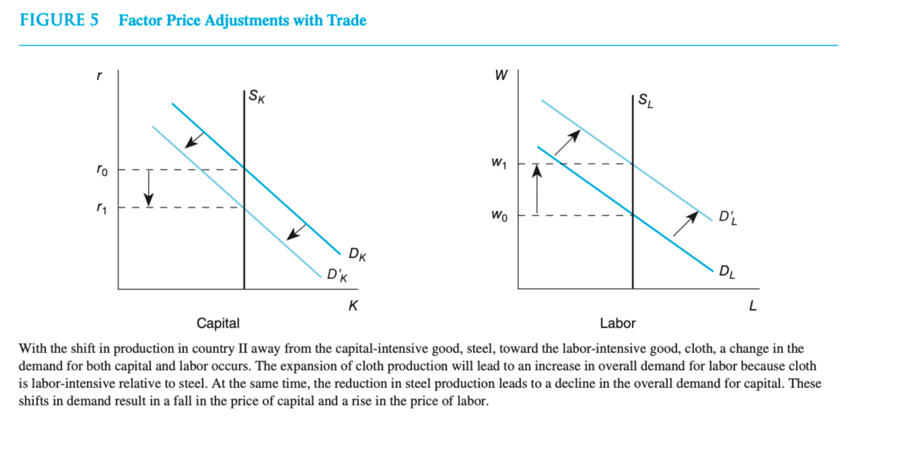
- Left: Capital Market (rental rate r)
Supply of capital Sk is vertical. Demand for capital shifts leftward when capital-intensive industries shrink. → Brexit interpretation: UK financial services, advanced manufacturing, and high-skill export sectors -traditionally capital-intensive-lose frictionless access to the EU market, reducing capital demand. Result: ro → r1 (real return to capital falls).
- Right: Labor Market (wage w) Supply of labor S, is vertical. Demand for labor shifts rightward when labor-intensive domestic production expands. → Brexit interpretation: Import-competing sectors-especially labor-intensive ones like food processing, low-tech manufacturing, basic consumer goods-become protected by new trade frictions, raising labor demand. Result: Wo → w1 (real wage rises).
Discuss:
Before Brexit, the UK benefited from seamless access to the EU’s single market, specializing in the sectors where it held a strong comparative advantage—financial services, pharmaceuticals, advanced manufacturing, aerospace, and other capital- and skill-intensive industries. These sectors exported heavily to the EU, sustained high productivity, and generated high returns to capital and skilled labor. At the same time, the UK imported a wide variety of labor-intensive and standardized goods from the EU at low cost, allowing domestic resources to remain concentrated in high-value activities.
Brexit introduces non-tariff barriers—custom checks, rules of origin, regulatory divergence—which raise the effective price of EU imports and reduce the competitiveness of UK exports. In the H-O–Stolper–Samuelson framework, this is equivalent to a rise in the relative price of UK import-competing, labor-intensive goods, and a fall in the relative price of UK export-oriented, capital-intensive goods. As a consequence, UK production shifts away from the high-productivity capital-intensive sectors that were previously oriented toward EU markets and toward domestic sectors that had been uncompetitive against EU producers.
Figure 5 captures this adjustment directly. When capital-intensive export industries contract, the demand curve for capital shifts left, reducing the rental rate. This matches empirical patterns: UK investment has lagged, high-skill service exports face new frictions, and Financial Times data show declining EU-bound capital-intensive exports. Simultaneously, domestic expansion in labor-intensive sectors increases labor demand, especially at the lower and middle part of the skill distribution, pushing the wage upward. This mechanism reflects real post-Brexit developments such as labor shortages in logistics and agriculture, higher costs in food production, and shifts in local manufacturing.
However, while some workers may gain, the UK’s aggregate welfare falls. The economy is now producing goods that EU partners can still produce at lower marginal cost. This misallocation raises domestic prices, reduces variety, and lowers real income. The capital-intensive sectors that previously drove UK productivity and export earnings shrink, eroding long-term growth potential. Even if certain workers see wage increases, the overall consumption possibilities of the UK lie on a lower indifference curve, as resources move out of highly competitive sectors and into less efficient ones.
Thus, Brexit reduces UK welfare not simply through lost market access, but by fundamentally shifting the country’s production structure toward sectors where it holds no comparative advantage. The Stolper–Samuelson model demonstrates why this shift compresses returns to capital while raising wages in protected sectors—and why the net effect for the UK economy is a reduction in total welfare.

- Why did Brexit push the UK and EU into a suboptimal equilibrium, and how can a Prisoner’s Dilemma framework explain the failure to maintain mutual gains from economic cooperation?

Define:
- Prisoner’s Dilemma (PD): A strategic interaction where two players would both be better off cooperating, but each faces strong incentives to defect, because defection offers a higher private payoff regardless of what the other side does.
- Cooperation in trade: Cooperation corresponds to maintaining low barriers, regulatory alignment, seamless market access, and shared institutions — all of which generate mutual gains through lower trade costs, economies of scale, and investment flows.
- Defection in trade negotiations: Defection corresponds to decisions such as pursuing sovereignty at the cost of alignment, imposing trade barriers, using threats, or refusing concessions. A country defects when it prioritizes unilateral control over joint economic efficiency.
- Suboptimal Nash equilibrium: A stable outcome where neither side can do better by changing strategy alone, but both would be better off if they coordinated. In the Brexit context, the UK and EU end up in a “low-integration” equilibrium even though a “high-integration” one is Pareto superior.

Diagram:
C = Cooperate (stay aligned / maintain deep integration)
D = Defect (prioritize sovereignty / impose barriers)
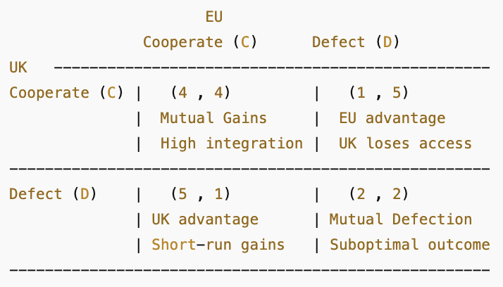
- (4,4) — Best joint outcome: both maintain deep alignment.
- (5,1) — UK defects, EU cooperates: UK gains short-run autonomy with near-full access (politically attractive).
- (1,5) — EU defects, UK cooperates: EU gains advantage; UK loses.
- (2,2) — Both defect: trade barriers, frictions, reduced coordination. This is the Brexit equilibrium.
Despite (4,4) being superior, the incentives push both players to (D,D) — the classic Prisoner’s Dilemma trap.

Discuss:
The interaction between the UK and the EU during the Brexit process mirrors a classic Prisoner’s Dilemma structure. Before Brexit, both parties occupied a cooperative position similar to the C–C outcome, benefiting from deep economic integration, frictionless trade and investment flows, harmonized regulations and access to a shared labor market. This arrangement maximized joint welfare: consumers in both markets enjoyed low prices and variety, firms operated across enlarged markets with reduced marginal costs, and both economies gained from scale, competition and specialization. In a game-theoretic sense, this cooperative equilibrium was Pareto superior, but it required both sides to remain aligned on rules, standards and institutions.
Despite these gains, the UK shifted to a defection strategy. Crucially, the EU did not push the UK toward exit; the move was initiated domestically because defection was politically attractive even though it implied economic risks. In the structure of the Prisoner’s Dilemma, the UK perceived a potentially favorable position in the D–C cell: by defecting while expecting the EU to remain cooperative, the UK leadership believed it could secure regained sovereignty, regulatory freedom and domestic political reward while still retaining many of the economic privileges of EU membership. The combination of domestic political incentives, electoral pressures and symbolic appeals made defection seem individually rational to the UK, even if economically inferior in the long run.
Initially, the EU maintained a cooperative posture, signaling willingness to keep trade smooth and minimize disruption. Yet once the UK formally defected, the EU could no longer sustain full cooperation without undermining its own institutional coherence. If a non-member could retain all the benefits of membership without the obligations, it would weaken the incentives for other member states to remain aligned. Thus, although the EU had no interest in punishing the UK, it was structurally compelled to respond to defection with defection. This dynamic shift converted the temporary D–C expectation into the long-run D–D equilibrium: a stable but suboptimal outcome characterized by new frictions, costly rules of origin, regulatory divergence and diminished mobility of goods, services, capital and labor.
The resulting equilibrium reproduces precisely what the Prisoner’s Dilemma predicts. Each side acted rationally given its own constraints: the UK maximized short-run political benefits, and the EU protected its institutional integrity. Yet jointly these choices produced a lower-welfare outcome. The UK, in particular, forfeited many of the privileges that defined the cooperative equilibrium—unrestricted market access, supply-chain integration and frictionless regulation—because mutual defection eliminates the gains from trade that cooperation once sustained. Brexit therefore reflects a strategic trap in which the pursuit of unilateral advantage leads to the collapse of a superior cooperative arrangement, pushing both parties into a stable but economically inferior equilibrium.

Epilogue
Taken together, the evidence suggests that Brexit has made the UK structurally poorer by reducing trade, investment and productivity relative to a counterfactual in which it remained inside the single market. The post-referendum depreciation, persistent trade frictions and weaker foreign investment flows have all narrowed the country’s economic opportunities and lowered real incomes.
The theoretical lenses reinforce this conclusion. Leaving the EU eliminated substantial trade-creation gains and pushed production toward less efficient domestic activities, while the recovery of earlier trade-diversion losses has been limited. The UK effectively exchanged deep, institutionalized cooperation for autonomy, but the strategic payoff resembles a lower-welfare equilibrium. The result is a smaller and less dynamic economy, shaped not by comparative advantage but by the frictions created in the aftermath of departure.

References
Devlin, K. (2025, November 25). Brexit costing the UK up to £90bn in lost tax a year, new analysis shows. The Independent. https://www.independent.co.uk/news/uk/politics/brexit-tax-rachel-reeves-budget-b2871536.html
Begg I. (2019). The impact of Brexit on growth and the public finances. SUERF – The European Money and Finance Forum. https://www.suerf.org/wp-content/uploads/2023/12/f_82836ca597a373e6c3cd5ae2d466161e_5471_suerf.pdf
L’Hotellerie-Fallois P. (2020). A review of economic analyses on the potential impact of Brexit (ECB Occasional Paper No. 249). European Central Bank. https://www.ecb.europa.eu/pub/pdf/scpops/ecb.op249~3538acd426.en.pdf
Bloom, N., Bunn P., Mizen, P., Smietanka, P., & Thwaites, G. (2025). The economic impact of Brexit (NBER Working Paper No. 34459). National Bureau of Economic Research. https://www.nber.org/system/files/working_papers/w34459/w34459.pdf
Gretter, G. (2025, May 13). Op-ed: Five years later — Was Brexit worth it? Michigan Journal of Economics. https://sites.lsa.umich.edu/mje/2025/05/13/op-ed-five-years-later-was-brexit-worth-it/
Springford, J. (2014). The economic consequences of leaving the EU. Centre for European Reform. https://www.cer.eu/sites/default/files/smc_final_report_june2014.pdf
Springford, J. (2025). The economic impact of Brexit, nine years on: Was the consensus right? The Constitution Society & The Federal Trust. https://consoc.org.uk/wp-content/uploads/2025/06/The-Economic-Impact-of-Brexit.pdf
Caldarini, A. (2021). Internationalisation of services: The economic impact of Brexit on the UK trade in services. Politecnico di Milano. https://www.politesi.polimi.it/retrieve/b770f69e-199e-4a0c-91d2-62a511e61840/Internationalisation%20of%20services_Economic%20impact%20of%20Brexit%20on%20the%20UK%20trade%20in%20services.pdf
Van Reenen, J. (2016). Brexit’s long-run effects on the UK economy. Brookings Institution. https://www.brookings.edu/wp-content/uploads/2017/02/brexits-long-run-effects-john-van-reenen.pdf
Armstrong, Angus, & Jonathan Portes. (2016). “Commentary: The Economic Consequences of Leaving the EU.” National Institute Economic Review 236: 2–6.
https://www.jstor.org/stable/i40184277
Breinlich, Holger, Dhingra, Sampson, & Van Reenen. (2016). “Who Bears the Pain? How the Costs of Brexit Would Be Distributed across Income Groups.” Brexit Analysis no. 7. London: London School of Economics. Centre for Economic Performance
https://cep.lse.ac.uk/pubs/download/brexit07.pdf
European Union. (n.d.). Key European Union achievements and tangible benefits. European Union. https://european-union.europa.eu/principles-countries-history/achievements_en
Ward, M. (2025). Foreign Direct Investment Statistics. House of Commons Library. UK Parliament. https://researchbriefings.files.parliament.uk/documents/CBP-8534/CBP-8534.pdf
Webb &Ward. (2021). Brexit: the Northern Ireland Protocol (Research Briefing CBP-7851). House of Commons Library. https://researchbriefings.files.parliament.uk/documents/CBP-7851/CBP-7851.pdf
Wikipedia. (n.d.). Causes of the vote in favor of Brexit. The Free Encyclopedia. https://en.wikipedia.org/wiki/Causes_of_the_vote_in_favour_of_Brexit
Islam, F & Smith, O. (2025, April 25). Rachel Reeves suggests UK trade with EU more important than US. BBC News. https://www.bbc.com/news/articles/c99p5nrr53mo

